Title or Task: | Writing a Resume  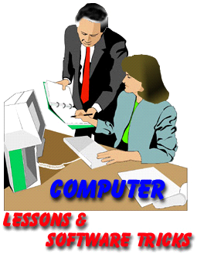

Description:

Files Required
Suitable for Classes: | Student Survival Kit
Area: | Technology & Enterprise
Teacher: | Mr Peter Faulks

Timeline

Date Due:

Task Brief:

Outcomes:

Items highlighted in yellow are tasks for you to complete
Items in Purple are help tips

Task: Making A Résumé, applying for a job, making the envelope…

Find a professional job advertised, (bring in a newspaper) and apply for the job completing the essential criteria required, make a résumé (make it up if you have to) Complete the package including an envelope to the company.

Resumes

http://jobsearch.about.com/od/resumes/a/resumecenter.htm

Create a Resume Template using Word save as a Template

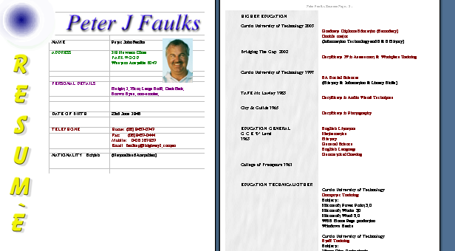

Use the following worksheet to help you

Making a resume worksheet (Microsoft Word)
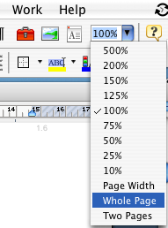
Open Microsoft Word

Click on New (Blank Document)

Click on Page Set-up

Select Landscape

Click view show whole page

Select insert Text box or draw a text box draw this to fill most of the right side of the page

Click inside the text box and insert table 2 columns and 2 rows Click O.K.

Select the top row and from Table menu click on merge cells

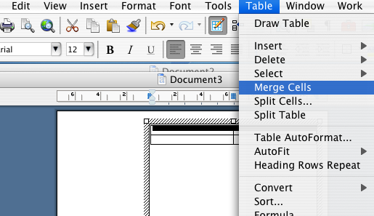

Your page should look like this:

Picture here or RESUME text Details here Your Name here



Type your name in the top row so that it fits across the full width
Ima Goodkid
(Use Word Art or a nice font)

Click in the next cell under and type Address in the same font but smaller

Now press tab twice and it will put in another line, add the following in each extra line that has been added

Contact Information
The first section of your resume should include information on how the employer can contact you.

- First Last Name (You have done this - to line)
- Address (Use your own)
- Street
- City, State, Postcode
- Phone (Mobile/Home)
- Email Address
Ima Goodkid
Address | 123 Good Street
City | Bateman WA 6111

Pages should be split as shown to give a split fill in details of whom you have worked for, experience etc. as a guide see below:

Education
In the education section of your resume, list the colleges you attended, the degrees you attained, and any special awards and honours you earned.

Education: Year completed,
Award, School's Name, City, State

Also, list two or three courses which would impress an employer

College, Degree
Awards, Honours

Skills
Include skills related to the position/career field that you are applying for i.e. computer skills, language skills.

Name the second skill needed for your occupation and give an example of how you have used it.

References available upon request
There is no need to include references on your resume. Rather, have a separate list of references to give to employers upon request.

Covering Letter of Application
You found a job from the newspaper now apply for that job: -

Your covering letter MUST address the expected criteria plus:

Objective (optional)
What do you want to do? If you include this section it should be a sentence or two about your employment goals. A customized objective that describes why you are the perfect candidate for the job can help your resume stand out from the competition.

Career Highlights / Qualifications (optional)
A customized section of your resume that lists key achievements, skills, traits, and experience relevant to the position for which you are applying can serve dual purposes. It highlights your relevant experience and lets the prospective employer know that you have taken the time to create a resume that shows how you are qualified for the job.

Experience
This section of your resume includes your work history. List the companies you worked for, dates of employment, the positions you held and a bulleted list of responsibilities and achievements.
Now fill in your resume
Company #1  City  State | Name here  City here  State etc. here
Dates Worked | Dates here
Job Title | Job Title Here
Responsibilities / Achievements | Here
Company #2  City  State | Name here  City here  State etc. here
Dates Worked | Dates here
Job Title | Job Title Here
Responsibilities / Achievements | Here

Work History:

Others you might use:
Duration,
Your title,
Brief job description,
Three or four responsibilities

Honors & Awards:
Clubs & Organizations:
Hobbies:
Referees:

Résumé
Company #1  City  State | Name here  City here  State etc. here
Dates Worked | Dates here
Job Title | Job Title Here
Responsibilities / Achievements | Here
Company #2  City  State | Name here  City here  State etc. here
Dates Worked | Dates here
Job Title | Job Title Here
Responsibilities / Achievements | Here



